1) ER Diagram for “UNIVERSITY database”
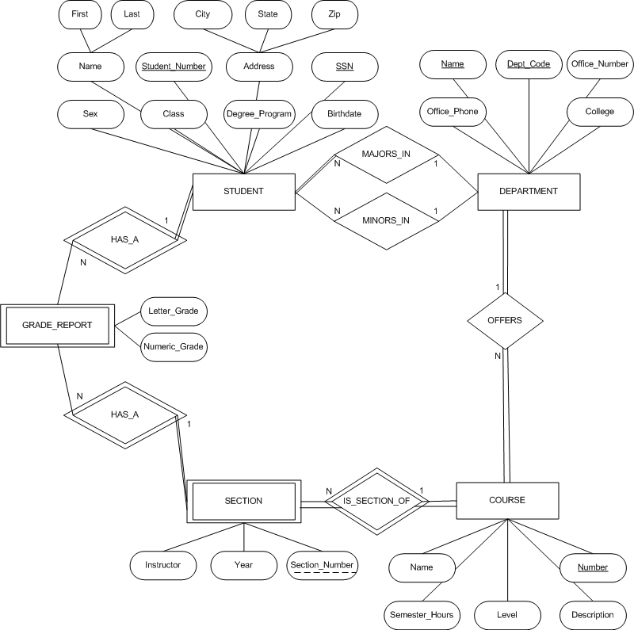

2) BANK database ER Diagram
a) List the (nonweak) entity types in the ER diagram
BANK, ACCTS, LOANS, and CUSTOMER
b) Is there a weak entity type? If so, give its name, partial key, and identifying relationship.
Yes, BANK_BRANCH is a weak entity type
name: BANK_BRANCH
partial_key: {BANK.Code, BANK_BRANCH.Branch_no}
identifying relationship: a BANK_BRANCH is a branch of a BANK
c) What constraints do the partial key and the identifying relationship of the weak entity type specify in this diagram?
Each BANK_BRANCH is uniquely identified by a branch_no and a BANK Code.
Each Bank Branch is a Branch of exactly 1 BANK.

